VersariteViewer: Post-Development Review
Design Criteria and Critical Functions
Oct 28, 2026 · @AJ

Purpose and scope
VersariteViewer is a native, fullscreen, mouse-driven Windows viewer for inspecting and sorting large collections of scientific images. One objective decides every design question: minimize the time between "interesting image" and "next image". The viewer views; file management stays in Total Commander.
This paper sets out retrospectively the design criteria behind release 1.3 and what had to be built to meet them. Details are in the developer specification (v1.5), the architecture document and the day logs (days 1 to 34).

Design criteria
The first principle, inherited from Hamana (Makito Miyano, 2006), is fast first, mouse first, never in the way. Every feature is tested against it: does the next image come sooner, can it be done with the mouse, and does it stay out of the way when not needed?
Criterion | What it requires | Target (spec §12)
The image wanted now beats everything | Preloads, folder scans, thumbnails and GPU uploads never delay the current image | Preloaded next image visible in the next frame
Never block the window | No disk access, decoding or long work on the UI thread | ≤ 8 ms of UI work per message
Cancel obsolete work at once | Every decoder checks a cancel flag every 16–32 rows | Holding the wheel leaves no queued lag
Feedback before quality | Preview, then screen-size copy, then full image, without the view jumping | Preview within ~50 ms where the file has one
Smooth view at any size | Pan, zoom and rotation change only a GPU transform; pixels are never resampled on the CPU | Every frame ≤ 16 ms
Mouse first | Every function reachable by wheel, click, gesture or screen zone; keyboard optional | —
No dead ends, no dialogs | Wrap-around browsing; notes on the info line instead of message boxes | —
A fault never costs a restart | Corrupt files, hung disks and stuck threads are contained | Shutdown within 4 s, emergency exit always available
Readable code | One responsibility per unit; every unit states Purpose, Owns, Knows, Does NOT, Threads | —
Lean | Single 64-bit exe, settings in an ini beside it, no registry, no heavy library overhead | —

Critical functions and what they require
Each critical function rests on a small number of mechanisms that must be in place before it works. They are listed in the order they were built.
Critical function | Must be implemented
Instant next image | A pool of decode workers (cores − 1, max 4) with one always kept free for the current image. A declarative scheduler: after every step it receives the set of images wanted (current, then ahead, then behind) and cancels, promotes or queues to match, so fast scrolling needs no special case. A cache evicted by distance from the current image, not by age.
First image fast | The scanner thread resolves the start path and delivers the start folder's list first, the full tree later. The first decode starts before any folder is scanned.
Quality in steps | Three levels: embedded thumbnail, screen-size copy (shrunk on the worker, drawn 1:1), full image. Band-wise decoding so the screen copy never allocates the full image (17 MB instead of 430 MB for a 108 MP TIFF).
Smooth pan and zoom on huge images | OpenGL textures in 1024-pixel tiles with mipmaps and 1-pixel overlap; uploads time-sliced (12 ms per frame), tiles nearest the view centre first; nearest filtering at 1:1 and above 400 %. A CPU renderer with the same interface as fallback.
Fast format readers | Own readers where speed matters: row-skipping and parallel-LZW TIFF, GIF, cancellable JPEG; Windows WIC in bands for the rest.
Folder trees of any size | Navigation as index arithmetic over immutable snapshots from the scanner; the window never touches the disk. An I/O gate pauses the scanner and preloads while the current image is read. Steps requested before the tree is ready are kept and carried out when it arrives.
Mouse control | Every input becomes a named command. A mouse engine turns wheel, tilt, side buttons, gestures and four screen zones into commands, following a readable profile file.
Fault containment | A stuck-read check (20 s) that replaces a hung worker; a memory guard refusing decodes that cannot fit; a watchdog thread with an emergency-exit hotkey and a 4 s shutdown deadline; settings written atomically (temp file, flush, replace).
Workflow with Total Commander | Side-by-side start, following Total Commander's cursor (5 polls a second), dir preview of the folder under its cursor, single instance receiving paths from new launches.
Sorting at the bench | A sort panel at the screen edge: one click moves or copies the image to a destination folder on a mover thread, never overwriting, with undo and a log.
Beyond still images | GIF animation from palette-indexed frames on a UI timer; STL models drawn live on the GPU (vertex buffers, shaders, stencil-closed section) with a sharp picture made on a thread; long jobs such as GIF combining on their own thread with progress and cancel.

Architecture that carries the criteria
The criteria are enforced by structure, not by care in each feature: only the UI thread touches the window, and everything slow runs on a thread that cannot reach it.
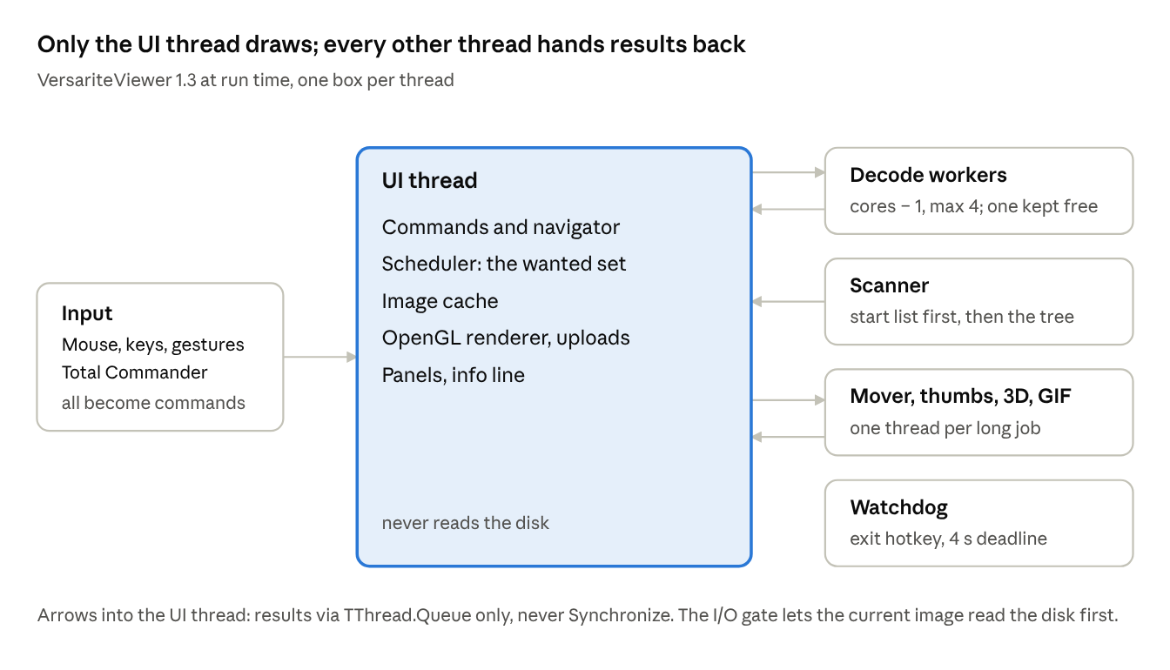
Run-time architecture · threads and what they hand back
Threads share only immutable objects (decoded images, folder lists); locks exist in a few named places (job queue, image cache, scanner, I/O gate). Input sources only produce commands, decoding knows nothing of the window, and rendering knows nothing of files. The 62 units form layers with no dependency cycles, so the microscopy edition plugs in through extension points without the core naming it.

Verification
Every criterion is checked by measurement or by an automated test, not by impression. Timing logs (timing.csv, startup.csv) and an on-screen diagnostics line (frame, decode and upload times, queue depth, cache size, browse or skim mode) are the main tools.
Test program | Checks at 1.3 | Covers
TestSort | 172 | Copy, move, undo, the mover thread, sort-folder lists
TestNavigation | 153 | Wrap-around, natural sort, empty folders, navigation without disk access, files moved away and back
TestMouse | 98 | Profile parsing, zones, clicks, gestures, the Hamana profile
TestExtensions | 80 | The plug-in points used by the microscopy edition
TestGifJoin | 32 | Combining GIFs, progress per frame, cancel leaves no file
TestStl | 25 | STL reading and the 3D view
Earlier releases added TestExif, TestGif (a reference GIF suite, 300 random corruptions) and TestFilters. Measured results on a GTX 960M laptop include 0–8 ms for a preloaded next image, a 4 ms quick-view paint and 168–368 ms for the quick view of a 324 MB, 108 MP TIFF.

Lessons from the design process
The 34 day logs show that most rules in this paper were learned from a failure in daily use, then made general.
- Measure before changing. When the 3D view felt slower than a dedicated STL viewer, both drew a 180,000-triangle model in the same 178–180 ms. The lag was in VersariteViewer's own overhead (panel redraws, picture uploads), not in the drawing.
- State what is wanted, not what to do. The declarative wanted set made skimming, direction changes and cancellation fall out of one reconcile step.
- Keep the disk off the window thread completely. A corrupt JPEG that froze the program (reported 2026-09-27) led to the no-disk rule, the stuck-read check and the watchdog.
- Any long job gets its own thread from the start. Combining GIFs on the window thread hung the program (day 34); streaming one frame at a time on a worker fixed it.
- Users decide. The start mode, climbing up folders, the slide show overriding the dir preview and the sort panel all came from testers' reports.
- Document every decision with its reason. The specification marks each one [Decision] or [Open], and every unit header says what the unit does not do.

